PERFORMANCE AND TESTING

Date | 27-01-2026
Team ID | LTVIP2026TMIDS26598
Project Name | Prevent User Deletion if Assigned to  Incident
Maximum Marks | 4 Marks

Model Performance Testing
User Creation
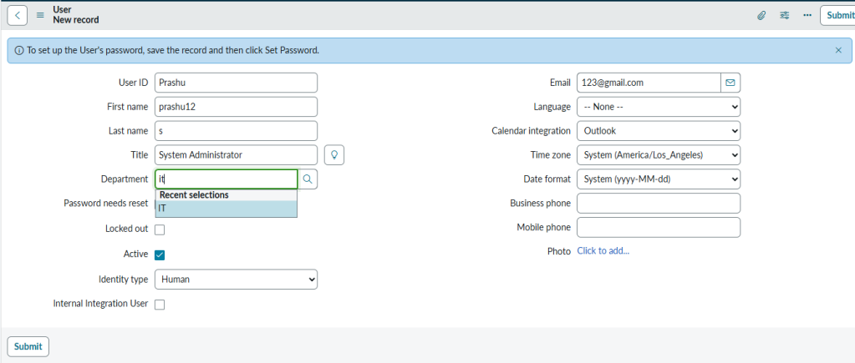

Assign Incident To User
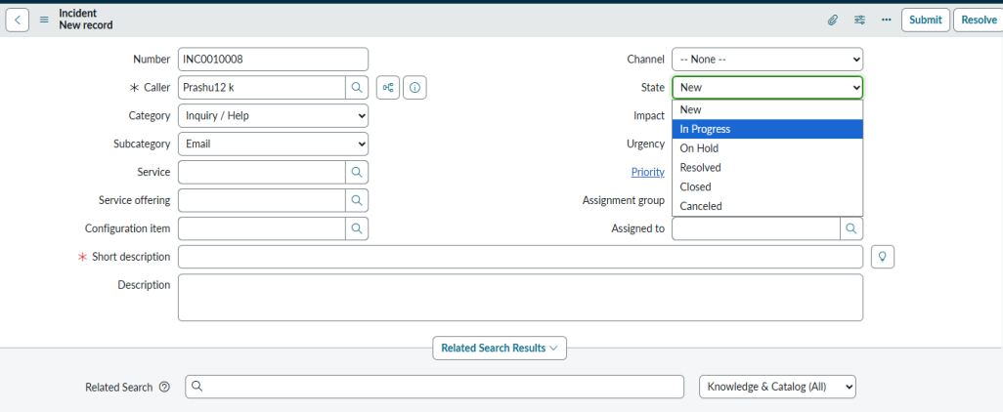

Business Rule Creation

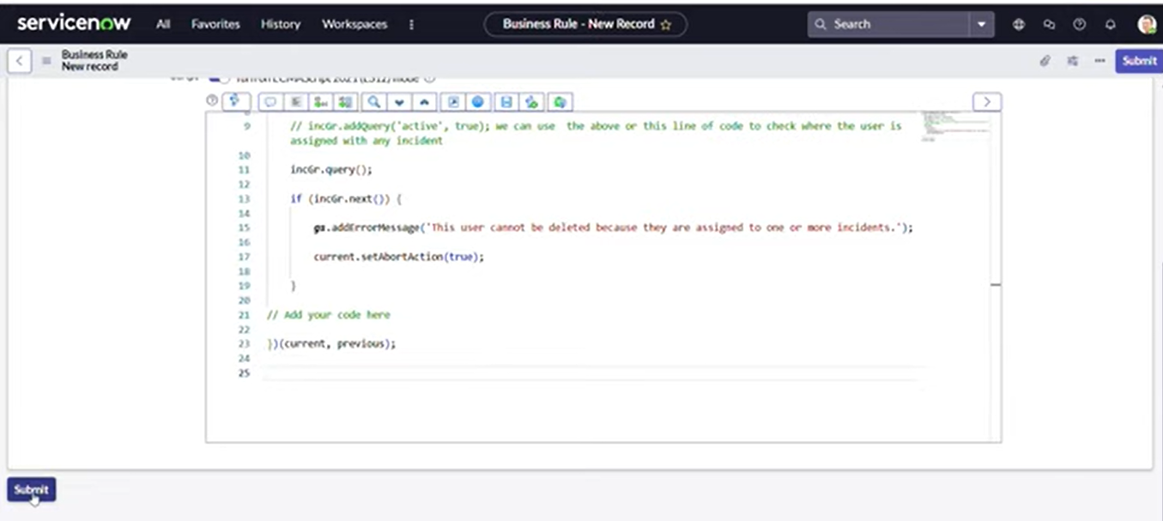

Test Deletion
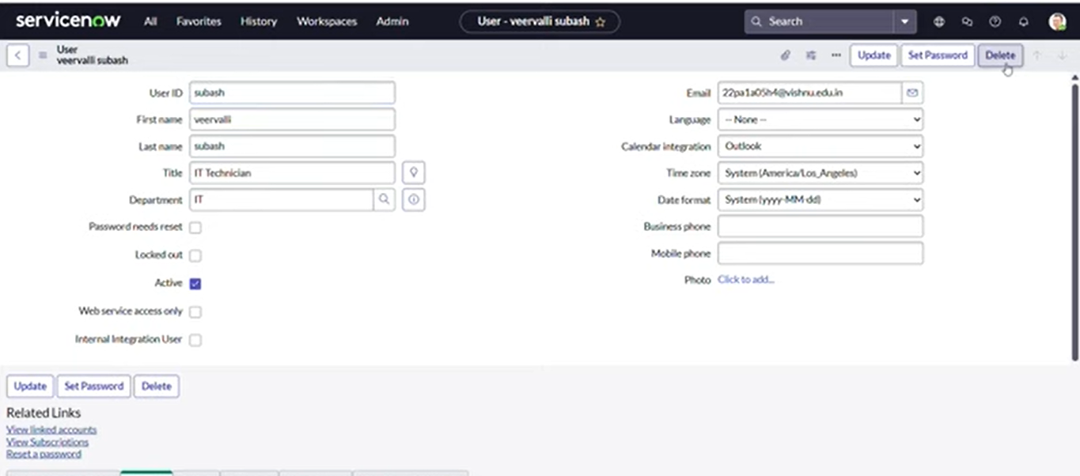

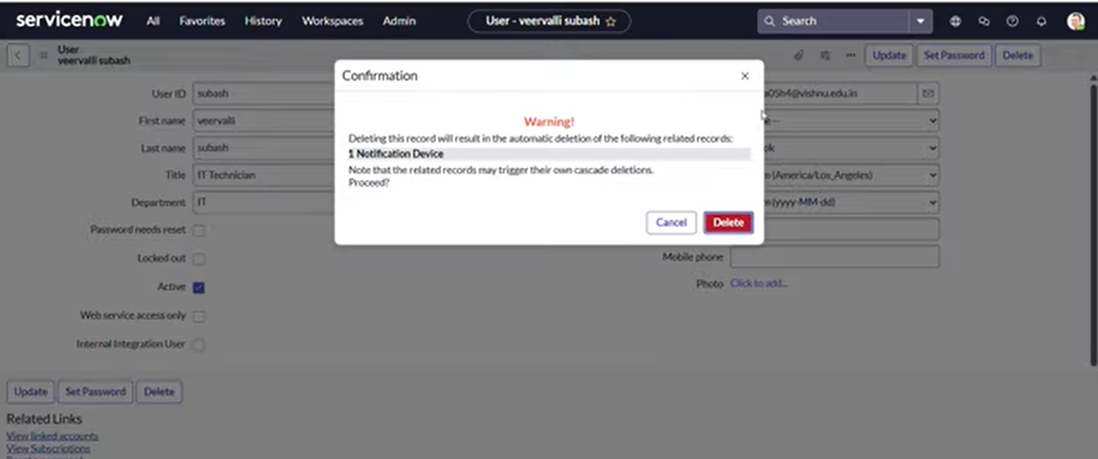

Test With Unassigned User

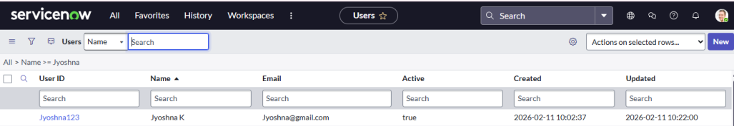

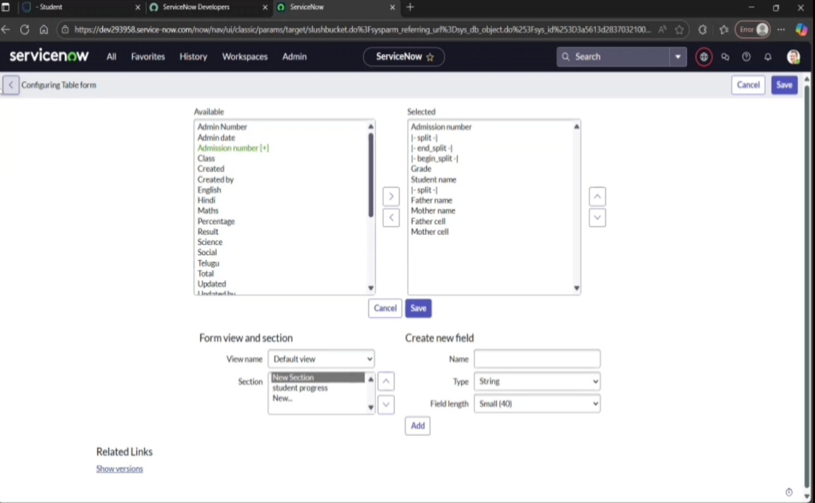

Parameters And Values
Explanation
- These parameters represent the key measurable and configurable elements used in your ServiceNow Incident Management project.
- Each value can be customized based on the organization’s IT policies and data governance rules.
- Using these parameters ensures the system is secure, reliable, scalable, and maintains data integrity..

